Nelson Urquilla
Agapitus Iboro

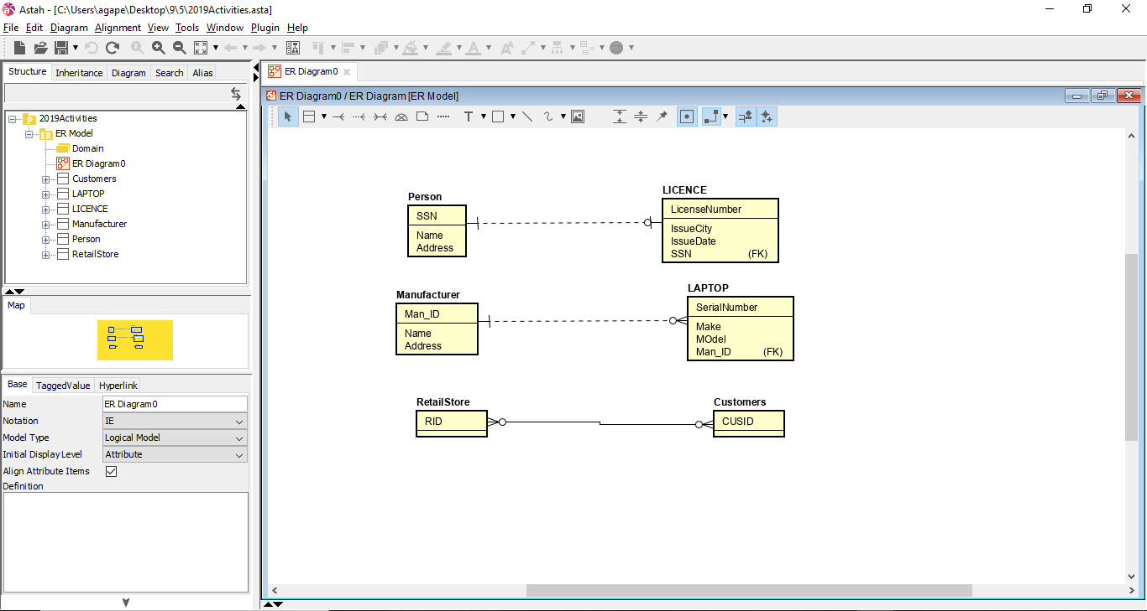

4.) BOAT (LicenseNumber, Type, Length)
BOAT _ OWNER (LicenseNumber, OwnerID) FK LicenseNumber BOAT, FK OwnerID OWNER
OWNER (OwnerID, Last Name, First Name, Phone, Email Address)

5.) The subtype relationship is exclusive this is because the main entity can only be either a house or a property.

6.) PROPERTY (PropertyID, Property Type, Address, City, State, ZIP)
HOUSE (PropertyID, Number of Bedrooms, Other Attributes) FK PropertyID PROPERTY
COMMERCIAL (PropertyID, Number of Units, Total Floor Space, Other Attributes) FK PropertyID PROPERTY.

7.) This relation would be a one to many relationship and this is because Each faculty can have one and only one faculty mentor while each faculty mentor can have one faculty or more.

